[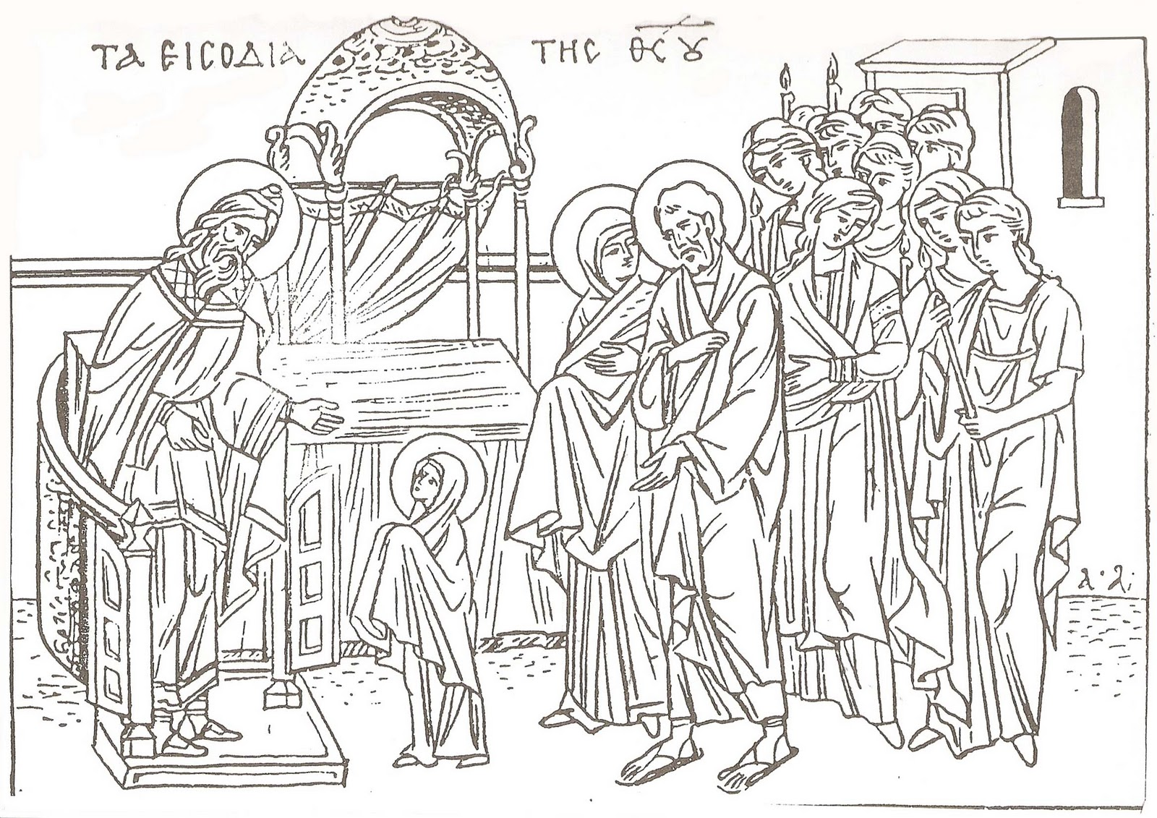](https://www.google.com.cy/url?sa=i&rct=j&q=&esrc=s&source=images&cd=&cad=rja&uact=8&ved=0ahUKEwjt6YjTrbnQAhWHvRQKHYF-Cs0QjRwIBw&url=https%3A%2F%2Fantexoume.wordpress.com%2F2013%2F11%2F20%2F%25CF%2584%25CE%25B1-%25CE%25B5%25CE%25B9%25CF%2583%25CF%258C%25CE%25B4%25CE%25B9%25CE%25B1-%25CF%2584%25CE%25B7%25CF%2582-%25CE%25B8%25CE%25B5%25CE%25BF%25CF%2584%25CF%258C%25CE%25BA%25CE%25BF%25CF%2585-%25CF%2580%25CF%2581%25CE%25BF%25CE%25B5%25CF%2584%25CE%25BF%25CE%25B9%25CE%25BC%25CE%25B1%25CF%2583%25CE%25AF%25CE%25B1%2F&psig=AFQjCNHyO6SH1Vtkc7TNXSfNxpBRSDm1UQ&ust=1479800783249785)