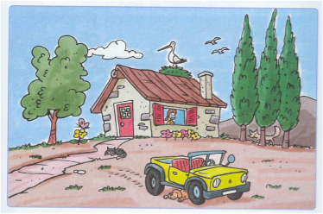
Περιγράφω την εικόνα χρησιμοποιώντας τοπικά επιρρήματα όπως: πάνω, κάτω, πίσω, δίπλα, ανάμεσα, εκεί, εδώ, μέσα, έξω, κοντά, μακριά κτλ.

______________________________________________________________________________________________________________________________________________________________________________________________________________________________________________________________________________________________________________________________________________________________________________________________________________________________________________________________________________________________________________________________________________________________________________________________________________________________________________________________________________________________________________________________________________________________________________________________________________________________________________________________________________________________________

