Παράγραφος 1^{η}
Γράφω γενικές πληροφορίες για τον κοροναϊό. Τι άκουσα από την τηλεόραση και το ραδιόφωνο; Τι διάβασα από το διαδίκτυο;
Λεξιλόγιο: πόλη Wuhan,επαρχία Hubei, Κίνα, εμφανίστηκε , συρροή κρουσμάτων πνευμονίας, πρόκειται για νέο στέλεχος κοροναϊού (Covid-19), οι κοροναϊοί είναι μία ομάδα ιών που συνήθως προκαλούν αναπνευστικές λοιμώξεις με ποικίλη σοβαρότητα στον άνθρωπο και στα ζώα, Ευρώπη, Παγκόσμιος Οργανισμός Υγείας, πανδημία, ταξιδιώτες, καραντίνα, προληπτικά μέτρα

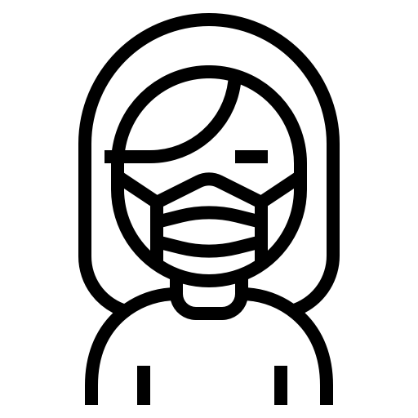
Παράγραφος 2^{η}
Γράφω τι έγινε στην Κύπρο όταν εμφανίστηκε ο ιός;
Τι άλλαξε στη ζωή μου;
Λεξιλόγιο:
Απαγορεύτηκαν οι εκκλησιασμοί, οι κοινωνικές εκδηλώσεις, οι επισκέψεις σε οικίες, σε πλατείες, πάρκα, έκλεισαν τα σχολεία, ελάχιστες δουλειές έμειναν ανοιχτές, καραντίνα, απαγόρευση γενικότερα της κυκλοφορίας, ουρές στις υπεραγορές και τα φαρμακεία, φοράμε μάσκες, πλένουμε τα χέρια μας τακτικά και σχολαστικά , χρησιμοποιούμε αλκοολούχου διάλυμα, αποφεύγουμε την επαφή των χεριών με τα μάτια, μύτη και στόμα, εάν εμφανίσουμε ήπια συμπτώματα λοίμωξης του αναπνευστικού (βήχας, καταρροή, πυρετός, πονόλαιμος) παραμένουμε στο σπίτι σε απομόνωση, σε περίπτωση επιδείνωσης των συμπτωμάτων ή εάν ανήκουμε σε ευπαθή ομάδα καλούμε 1420, δεν βλέπουμε τον παππού και τη γιαγιά γιατί ανήκουν στις ευπαθείς ομάδες, δεν έρχονται τουρίστες στο νησί μας, έκλεισαν τα αεροδρόμια, εξ αποστάσεως διδασκαλία , ακούγεται συνέχεια το σύνθημα: Μένουμε στο σπίτι

Παράγραφος 3^{η}
Γράφω τα συναισθήματά μου και συγκρίνω πώς ήταν η ζωή μου πριν την εμφάνιση του covid-19
Λεξιλόγιο:
φόβος και άγχος για μένα και τα αγαπημένα σου πρόσωπα, θλίψη και ανία, αίσθημα στέρησης της ελευθερίας, θυμός και εκνευρισμός λόγω περιορισμού στο σπίτι και στέρησης των αγαπημένων μου συνηθειών ( επίσκεψη σε πάρκα, παιδότοπους, στον παππού και στη γιαγιά, επίσκεψη στους φίλους μου, βόλτα στην Κάτω Πάφο, στο εμπορικό κέντρο κ.ά.

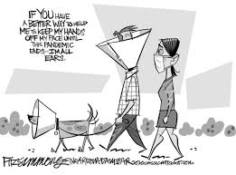
Παράγραφος 4^{η}
Γράφω κάποιες ευχές .
Λεξιλόγιο:
εύχομαι, σταματήσει, σύντομα, επανέλθει, ζωή, επιστήμονες, βρεθεί, εμβόλιο, θάνατοι, άνθρωποι, υγιείς.

………………………………………………………………………………………………………………………………………………………………………………………………………………………………
………………………………………………………………………………………………………………………………………………………………………………………………………………………………
………………………………………………………………………………………………………………………………………………………………………………………………………………………………
………………………………………………………………………………………………………………………………………………………………………………………………………………………………
………………………………………………………………………………………………………………………………………………………………………………………………………………………………
………………………………………………………………………………………………………………………………………………………………………………………………………………………………
………………………………………………………………………………………………………………………………………………………………………………………………………………………………
………………………………………………………………………………………………………………………………………………………………………………………………………………………………
………………………………………………………………………………………………………………………………………………………………………………………………………………………………
………………………………………………………………………………………………………………………………………………………………………………………………………………………………
………………………………………………………………………………………………………………………………………………………………………………………………………………………………
………………………………………………………………………………………………………………………………………………………………………………………………………………………………
………………………………………………………………………………………………………………………………………………………………………………………………………………………………
………………………………………………………………………………………………………………………………………………………………………………………………………………………………
………………………………………………………………………………………………………………………………………………………………………………………………………………………………
………………………………………………………………………………………………………………………………………………………………………………………………………………………………
………………………………………………………………………………………………………………………………………………………………………………………………………………………………
………………………………………………………………………………………………………………………………………………………………………………………………………………………………
………………………………………………………………………………………………………………………………………………………………………………………………………………………………
………………………………………………………………………………………………………………………………………………………………………………………………………………………………
………………………………………………………………………………………………………………………………………………………………………………………………………………………………
………………………………………………………………………………………………………………………………………………………………………………………………………………………………
………………………………………………………………………………………………………………………………………………………………………………………………………………………………
………………………………………………………………………………………………………………………………………………………………………………………………………………………………
………………………………………………………………………………………………………………………………………………………………………………………………………………………………
………………………………………………………………………………………………………………………………………………………………………………………………………………………………
………………………………………………………………………………………………………………………………………………………………………………………………………………………………
………………………………………………………………………………………………………………………………………………………………………………………………………………………………
………………………………………………………………………………………………………………………………………………………………………………………………………………………………
………………………………………………………………………………………………………………………………………………………………………………………………………………………………

