[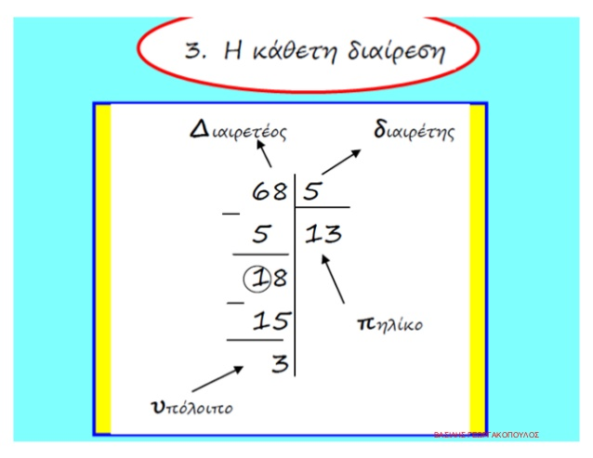](https://www.google.co.uk/url?sa=i&url=https%3A%2F%2Fwww.slideshare.net%2Fxristoasxar%2F2-13-67138467&psig=AOvVaw3GQMz8K3dYqktvRBtYN6yw&ust=1589257663432000&source=images&cd=vfe&ved=0CAIQjRxqFwoTCMCF97X8qukCFQAAAAAdAAAAABAE)

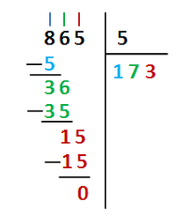

[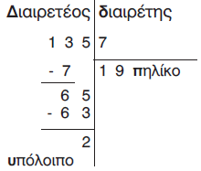](https://www.google.co.uk/url?sa=i&url=http%3A%2F%2Febooks.edu.gr%2Fmodules%2Febook%2Fshow.php%2FDSDIM-E113%2F796%2F5178%2C23738%2F&psig=AOvVaw2CYiLqAmM4O65E3YmuefPu&ust=1589258345675000&source=images&cd=vfe&ved=0CAIQjRxqFwoTCNjll_v-qukCFQAAAAAdAAAAABAL)

[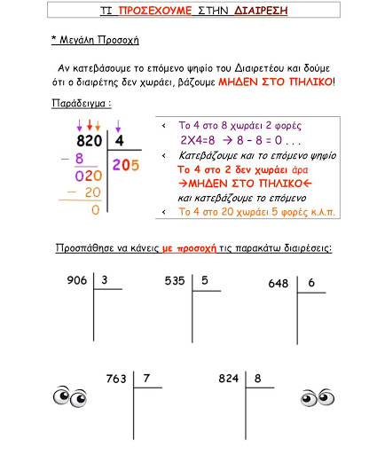](https://www.google.co.uk/url?sa=i&url=http%3A%2F%2Fdim-palouriotissa3-lef.schools.ac.cy%2Findex.php%3Fid%3Dd-taxe&psig=AOvVaw3GQMz8K3dYqktvRBtYN6yw&ust=1589257663432000&source=images&cd=vfe&ved=0CAIQjRxqGAoTCMCF97X8qukCFQAAAAAdAAAAABCAAg)