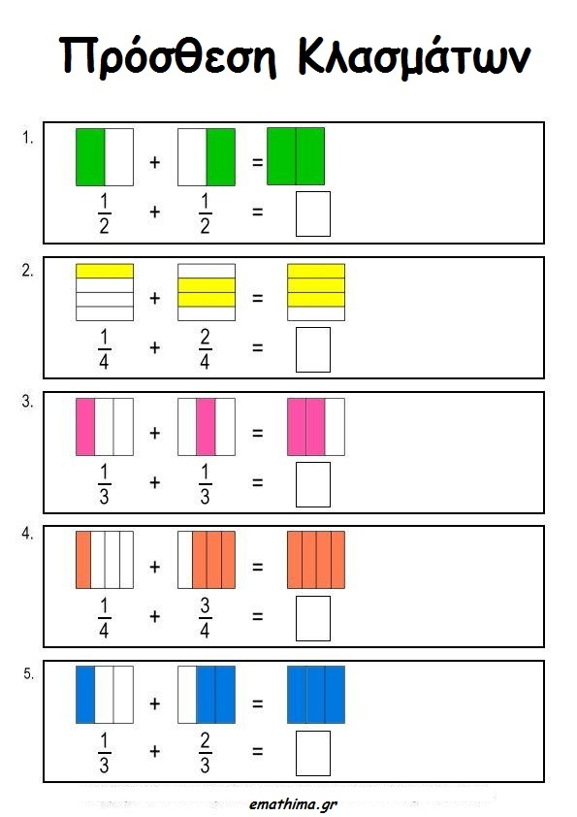

- Βρέστε τα ισοδύναμα κλάσματα με:
- Το $\frac{1}{2}$ = ......= ........= ............= ..........= .......... =............= ...........
- Το $\frac{1}{3}$ = ......= ........= ............= ..........= .......... =............= ...........
- Το $\frac{1}{4}$ = ......= ........= ............= ..........= .......... =............= ...........
- Το $\frac{1}{6}$ = ......= ........= ............= ..........= .......... =............= ...........
- Τα $\frac{2}{3}$ = ......= ........= ............= ..........= .......... =............= ...........
- Τα $\frac{3}{7}$ = ......= ........= ............= ..........= .......... =............= ...........
- Τα $\frac{4}{9}$ = ......= ........= ............= ..........= .......... =............= ...........

12141418231153428561123426391181214141823115342856112342639118
- Πρόσθεση και αφαίρεση ετερώνυμων κλασμάτων
$\frac{1}{2}$ + $\frac{1}{3}$ =
$\frac{1}{4}$ + $\frac{1}{8}$ =
$\frac{2}{5}$ + $\frac{1}{3}$ =
$\frac{3}{4}$ + $\frac{2}{6}$ =
$\frac{5}{6}$ + $\frac{1}{12}$ =
$\frac{3}{5}$ + $\frac{2}{7}$ =
$\frac{3}{8}$ + $\frac{1}{12}$ =
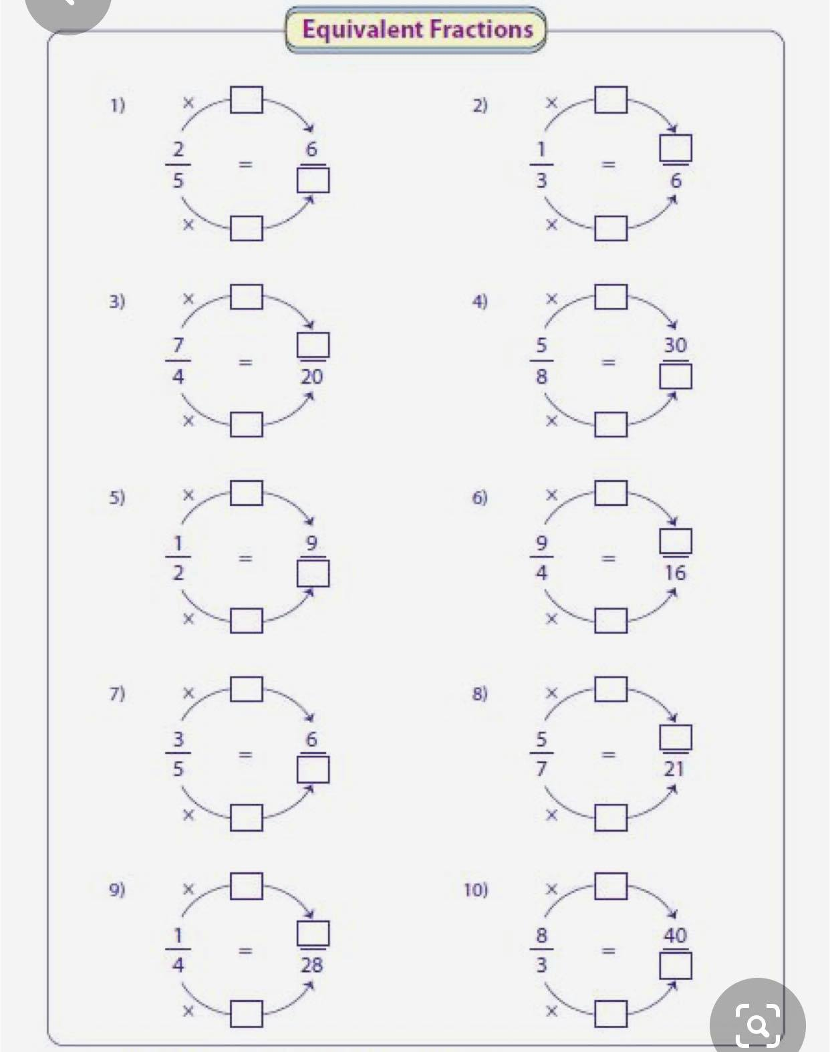
3
10
2

